**Assignment1**

**Ather alnami -2111453**

**EC8**

**Web page**

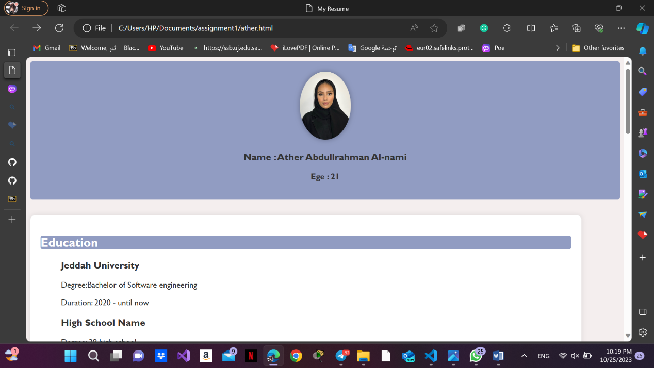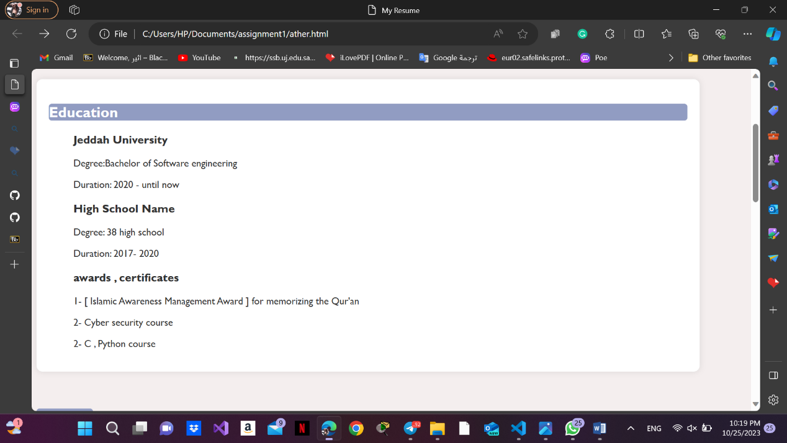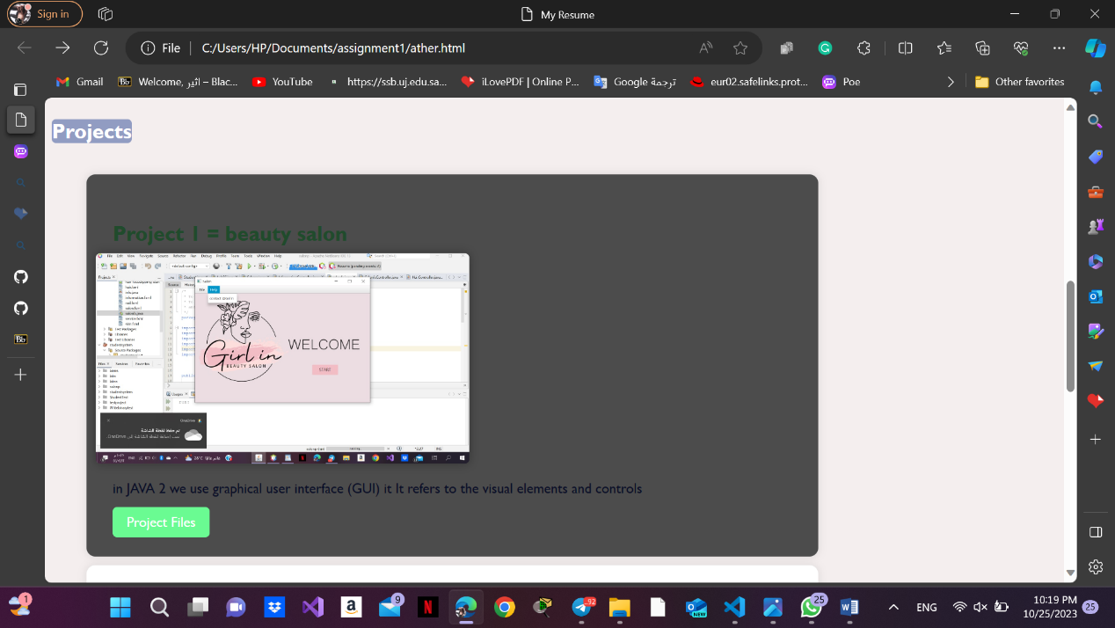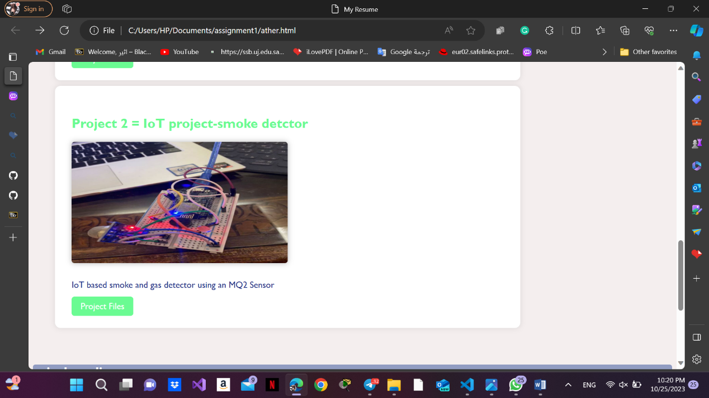

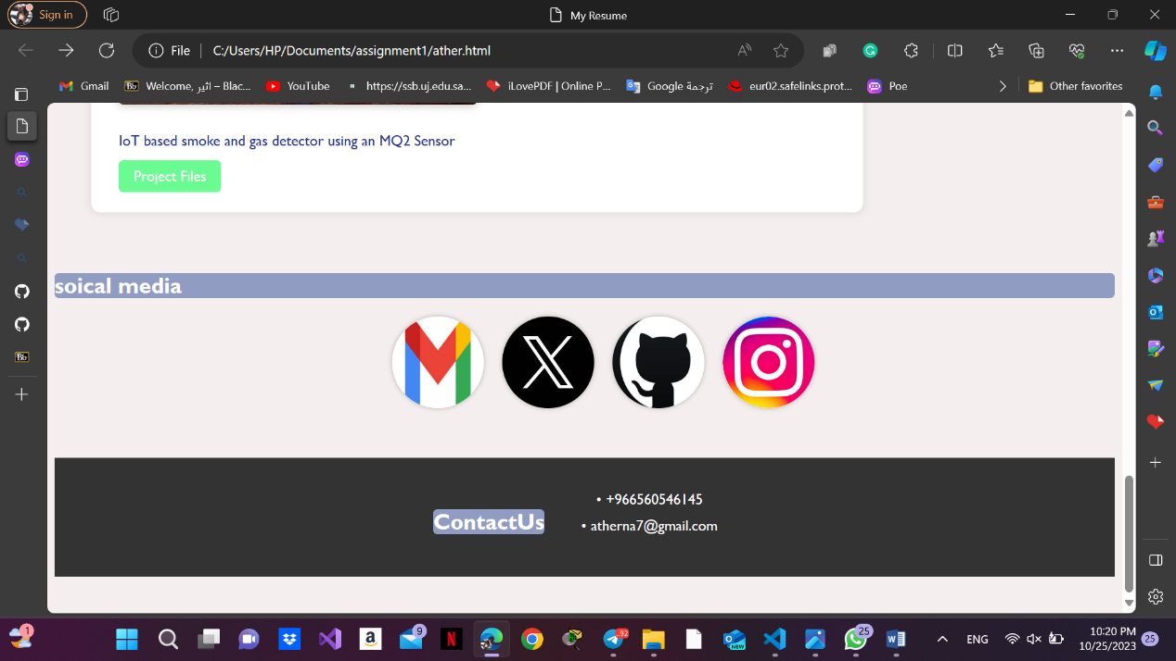

**HTML CODE:**

<!DOCTYPE html>

<html lang="en">

  <head>

    <meta charset="UTF-8" />

    <meta name="viewport" content="width=device-width, initial-scale=1.0" />

    <link rel="stylesheet" href="css/style.css" />

    <title>My Resume</title>

  </head>

  <body>

    <header>

      <img src="media/ather.jpg" alt="Profile Picture" />

      <h3>Name : Ather Abdullrahman Al-nami</h3>

      <strong>Ege : 21 </strong>

    </header>

    <section class="education">

      <h2>Education</h2>

      <ul>

        <li>

          <h3>Jeddah University</h3>

          <p>Degree:Bachelor of Software engineering</p>

          <p>Duration: 2020 - until now</p>

        </li>

        <li>

          <h3>High School Name</h3>

          <p>Degree: 38 high school</p>

          <p>Duration: 2017- 2020</p>

        </li>

        <li>

          <h3>awards , certificates</h3>

          <p>

            1- [ Islamic Awareness Management Award ] for memorizing the Qur'an

          </p>

          <p>2- Cyber security course</p>

          <p>2- C , Python course</p>

        </li>

      </ul>

    </section>

    <section class="projects" id="project">

      <h2>Projects</h2>

      <ul>

        <li class="project1">

          <h3>Project 1 = beauty salon</h3>

          <img

            src="media/project1.jpg"

            alt="Picture of the first project not found"/>

          <p>

            in JAVA 2 we use graphical user interface (GUI) it It refers to the

            visual elements and controls

          </p>

          <a href="media/salo_project.pdf">Project Files</a>

        </li>

        <li class="project2">

          <h3>Project 2 = IoT project-smoke detctor</h3>

          <img

            src="media/project2.jpg"

            alt="Picture of the Second project not found"/>

          <p>IoT based smoke and gas detector using an MQ2 Sensor</p>

          <a href="media/smoke_detctor.pdf">Project Files</a>

        </li>

      </ul>

    </section>

    <section class="social-media">

      <h2>soical media</h2>

      <ul>

        <li>

          <a href="mailto:atherna7@gmail.com"

            ><img src="media/gmail.jpg" alt="gmail"/></a>

        </li>

        <li>

          <a href="https://x.com/engath117"

            ><img src="media/x.jpg" alt="X"/></a>

        </li>

        <li>

          <a href="https://github.com/atherna7"

            ><img src="media/git.jpg" alt="github"/></a>

        </li>

        <li>

          <a href="https://instagram.com/engath17?igshid=MzRlODBiNWFlZA=="><img src="media/in.jpeg" alt="instagram"/></a>

        </li>

      </ul>

    </section>

    <footer class="contact" id="contacts">

      <h2>ContactUs</h2>

      <ul class="col">

        <li>+966560546145</li>

        <li>atherna7@gmail.com</li>

      </ul>

    </footer>

  </body>

</html>

**CSS CODE:**

/* Apply some basic styles to the page */

body {

  font-family:'Gill Sans', 'Gill Sans MT', 'Calibri', 'Trebuchet MS', sans-serif;

  background-color: #f4eeee;

  color: #333;

}

h2 {

  margin-top: 20px;

  color: #fff;

  background-color: #919cc2;

  border-radius: 5px;

}

header {

  text-align: center;

  margin-bottom: 30px;

  padding: 20px;

  background-color: #919cc2;

  border-radius: 5px;

}

img {

  max-width: 100px;

  border-radius: 50%;

  box-shadow: 0 0 10px rgba(0, 0, 0, 0.3);

}

.education, .projects, .social-media, .contact {

  margin-bottom: 40px;

}

ul {

  list-style-type: none;

}

li {

  margin-bottom: 10px;

}

 .education{

  width: 90%;

  padding: 20px;

  border-radius: 10px;

  background-color: #fff;

  box-shadow: 0 0 10px rgba(0, 0, 0, 0.1);

 }

/* project section */

.projects  {

  display: flex;

  flex-wrap: wrap;

  justify-content: space-between;

}

.projects li {

  width: 70%;

  padding: 30px;

  border-radius: 10px;

  background-color: #fff;

  box-shadow: 0 0 10px rgba(0, 0, 0, 0.1);

  transition: transform 0.3s ease;

  position: relative;

  overflow: hidden;

}

.projects li:before {

  content: '';

  position: absolute;

  top: 0;

  left: 0;

  width: 100%;

  height: 100%;

  background-color: rgba(0, 0, 0, 0.7);

  opacity: 0;

  transition: opacity 0.3s ease;

}

.projects li:hover:before {

  opacity: 1;

}

.projects li h3 {

  font-size: 24px;

  margin-bottom: 20px;

  color: #6afb92;

  z-index: 1;

}

.projects li p {

  color: #1f3488;

  margin-bottom: 20px;

  z-index: 1;

}

.projects li img {

  max-width: 50%;

  border-radius: 5px;

  margin-bottom: 10px;

  transition: transform 0.3s ease;

}

.projects li a {

  color: #fff;

  text-decoration: none;

  background-color: #6afb92;

  padding: 8px 16px;

  border-radius: 5px;

  transition: background-color 0.3s ease;

  position: relative;

  z-index: 1;

}

.projects li:hover img {

  transform: scale(1.1);

}

.projects li a:hover {

  background-color:#737ca1;

}

/* social media section */

.social-media ul {

  display: flex;

  justify-content: center;

  align-items: center;

  flex-wrap: wrap;

  gap: 20px;

}

.social-media ul li img {

  width: 100px;

  height: 100px;

  border-radius: 50%;

  box-shadow: 0 0 5px rgba(0, 0, 0, 0.3);

}

/* contacct section */

footer {

  background-color: #333;

  color: #fff;

  padding: 20px;

  text-align: center;

}

.contact {

  display: flex;

  justify-content: center;

  align-items: center;

  flex-wrap: wrap;

}

.contact h2 {

  margin-bottom: 10px;

  color: #fff;

}

.contact ul {

  display: flex;

  justify-content: center;

  align-items: center;

  flex-direction: column;

}

.contact li {

  margin-bottom: 10px;

}

.contact .col {

  display: flex;

  flex-wrap: wrap;

  justify-content: center;

}

.contact .col li {

  margin-right: 20px;

}

.contact .col li:before {

  content: '\2022';

  margin-right: 5px;

}

/* Responsive Styles */

/* For screens smaller than 576px */

@media (max-width: 575px) {

  /* Adjust the width of project list items to 100% */

  .projects li {

    width: 100%;

  }

  /* Adjust the width of project images to auto */

     .projects li img {

      width: auto;

      height: auto;

    }

    /* Adjust the text alignment in the contact section */

    .contact ul {

      text-align: center;

    }

    .contact .col {

      flex-direction: column;

      align-items: center;

    }

}

/* For screens between 576px and 767px */

@media (min-width: 576px) and (max-width: 767px) {

  /* Adjust the width of project list items to 50% */

  .projects li {

    width: 50%;

  }

  /* Adjust the width of project images to 200px */

  .projects li img {

    width: 200px;

    height: auto;

  }

}

/* For screens between 768px and 991px */

@media (min-width: 768px) and (max-width: 991px) {

  /* Adjust the width of project list items to 50% */

  .projects li {

    width: 50%;

  }

}

/* For screens larger than 992px, use the default styles */

**HTML Validation:**

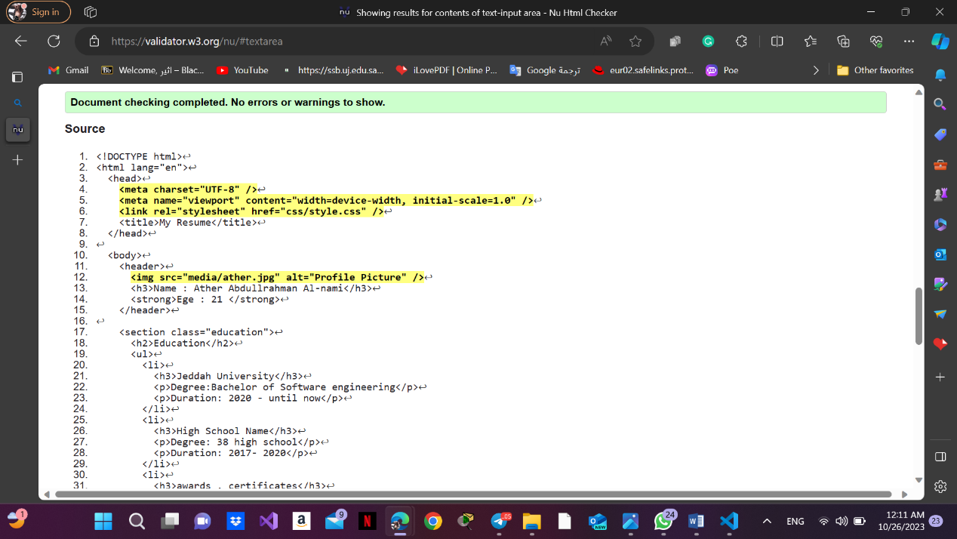

**CSS Validation:**

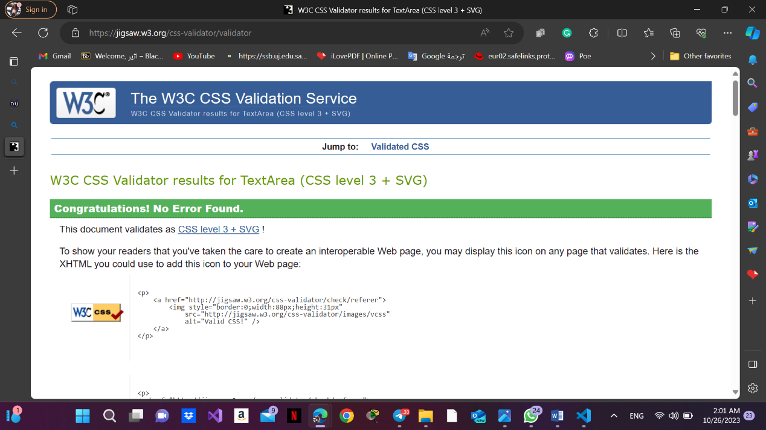

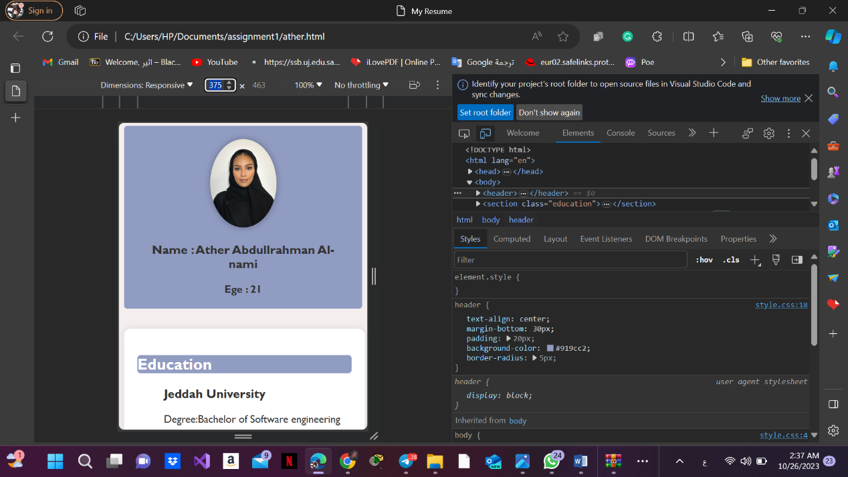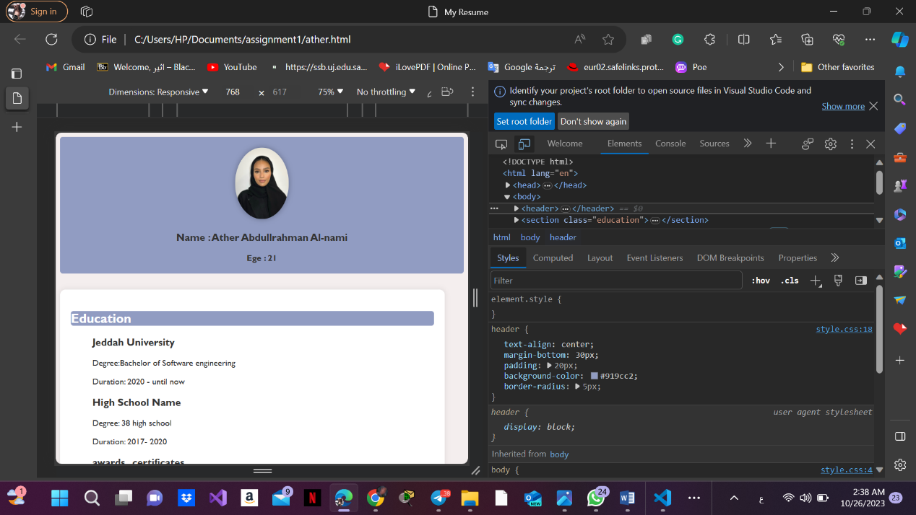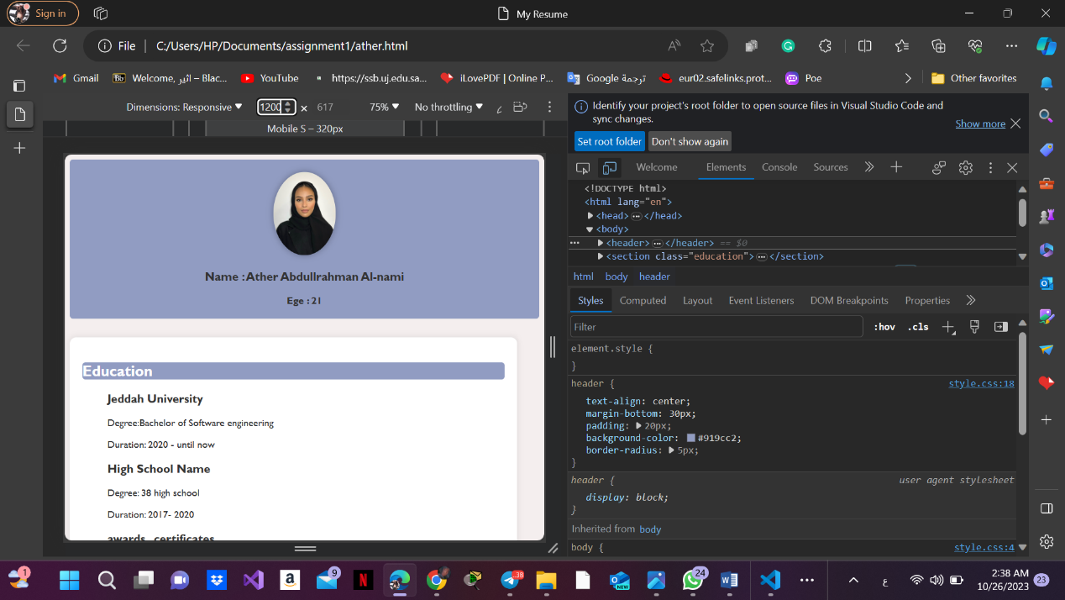

**Github:**

[atherna7/My-Personal-Resume (github.com)](https://github.com/atherna7/My-Personal-Resume)